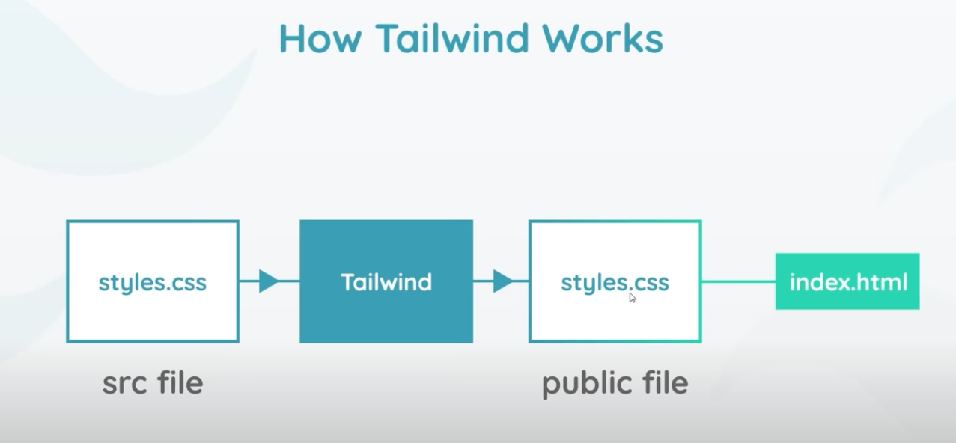

**Installation**:

It needs a transpiler to convert it to CSS. Installation process in visual studio code is below:

* Install node /npm
* npm install -D tailwindcss@latest postcss@latest autoprefixer@latest
* Then in the package.json file we can write the script to build the tailwind css

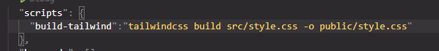

* This specifies the source folder first, then which folder to output the file.
* When building for production, we can specify purge to make it exclude the unused classes.

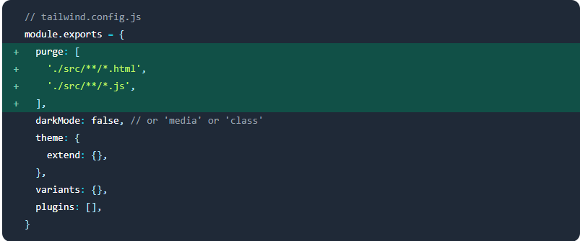

**Tailwind Config:**

* **npx tailwindcss init –full**
* This instruction will create a configuration file with full default values for the tailwind css. We can keep this file as a reference, and rename it as default or something.
* Then we can run the same command without the –full, and get a empty file. Here we can define our own customization, plugins etc.

**@Apply:**

* If we want a specific class to have a set of classes in it (for example, a card or buton etc ), then we can edit them in the style source file. So when we assign card class to any element, it will apply all these classes.

